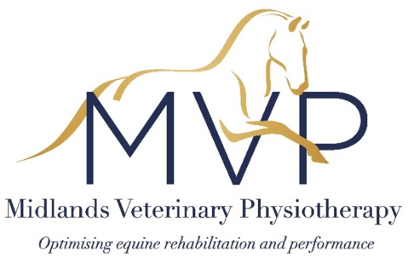 |  |  |  |  | Midlands Veterinary Physiotherapy  Member of the NAVP, MAA and IAVRPT  RAMP and AHPR registered  07753 747467  hannah@midlandsvetphysio.co.uk  www.midlandsvetphysio.co.uk
Owner Name:
Horse Name:
Date of Birth: |  |  |  |  | Height: |  |  |  |  |  | Sex:
Breed: |  |  |  |  |  |  | Colour:
Reason for referral/consent: | Treatment for a specific problem  (please answer all below) |  |  |  |  |  |  |  |  | Routine ‘maintenance’ care  (please answer 3&4 below)
- Insurance Claim: | Y/N |  |  | Company (& claim ref. if known):
- Nature of current problem(s) including any investigations performed and diagnosis if applicable:

- Current medication(s):

- Details of any pre-existing conditions or past medical history (including any previous lameness):

Any other comments (e.g. specific precautions, plans for further veterinary examination or treatment):

I believe the above horse to be a suitable candidate for physiotherapy care as deemed appropriate following an assessment by Hannah Haskew of Midlands Veterinary Physiotherapy. In giving this consent, I understand that Hannah Haskew is responsible for any such work carried out and holds appropriate professional liability insurance.
Signature: |  |  |  |  |  |  |  |  |  |  |  |  | Date:
Name:
Practice Name:
Practice Address:
Phone Number: |  |  |  |  |  | Email:

